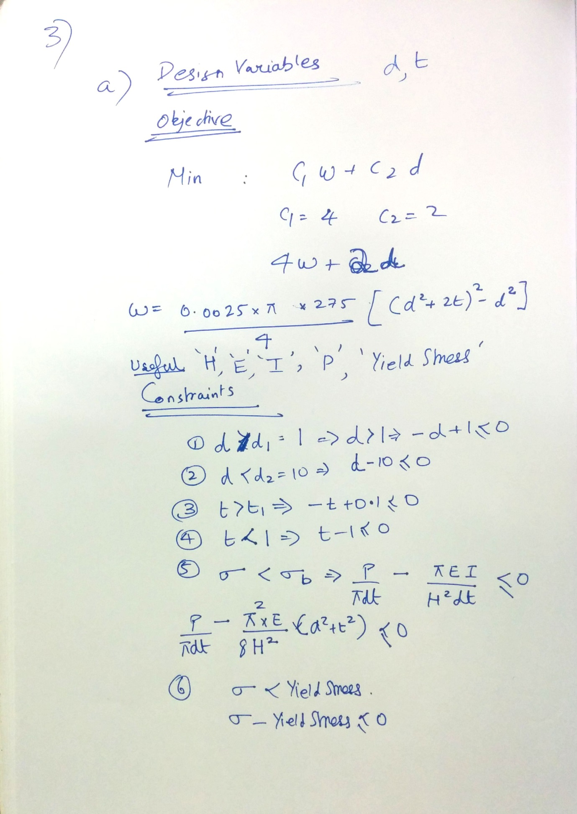

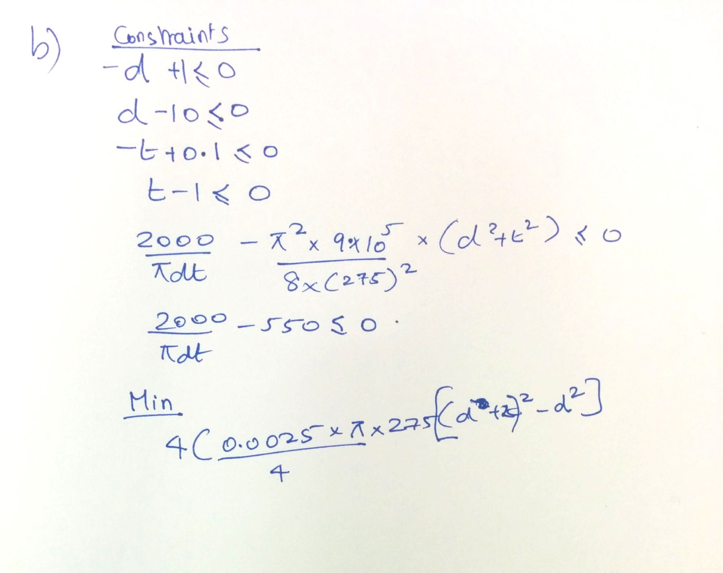

The d, t values are:

|  |
| --- |
| 6.117589 |
| 0.189207 |

c) Please check the matlab files in q3 folder

mainscript-🡪 Run

confun-🡪 function for non- linear inequality

objecfun-🡪 function for linear inequality

x = 3.4269 0.9938

fval = 44.8104

d) Please check the same files again

x2=6.1176 0.1892

fval2 =22.5445

(e) Yes results agree except for Active-Set

After changing initial values to 5 and 0.9

**Excel does not change answer**

|  |
| --- |
| 6.117589 |
| 0.189207 |

**Active set becomes better**

x3 =6.1176 0.1892

fval3 = 22.5445

**SQP remains same**

x4 =6.1176 0.1892

fval4 =22.5445